1. Launching Ec2 user   
Adding New User Techie – adduser space Username

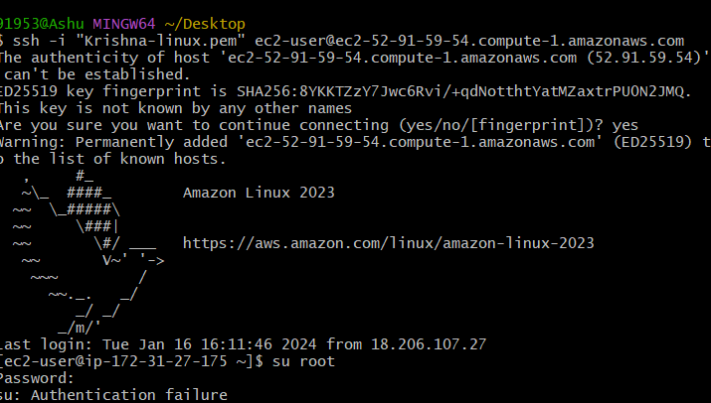

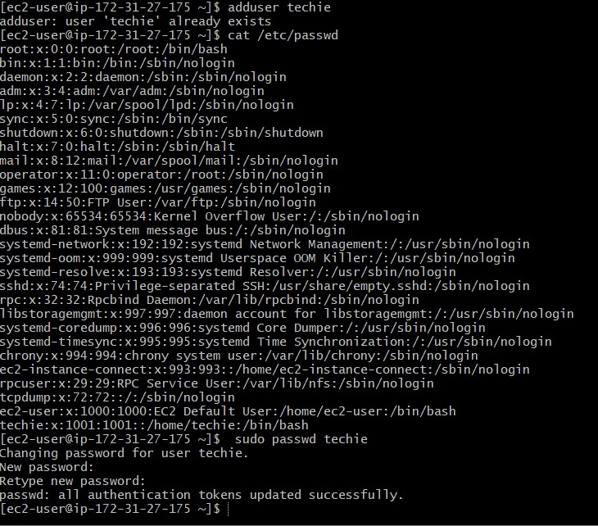

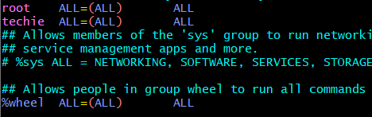

2.Give access to sudo to techie

3. Create a new directory



 4. List the contents of a directory.

5.Change the current directory.



6. Create a new empty file.

By using the touch command we can create the empty file



7. View the contents of a file.

To read the file what we are going to be write

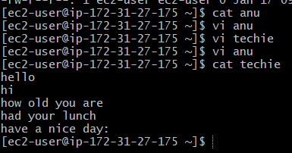

8. Copy a file to another location.

We have copy a file to another directory

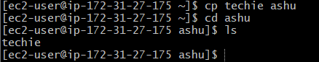

9. Move a file to another location.

We have to move a file to another directory 03 is the location

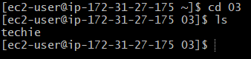

10.Rename a file (we have to rename a file by using mv command Naveen is renamed by Praveen then Naveen is the rename file

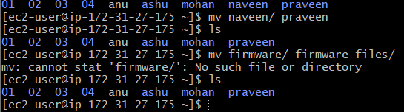

11.Delete a file

We need to delete a file with help of rm command then I use to delete the anu file then we have to check LL(to check the long list of files)

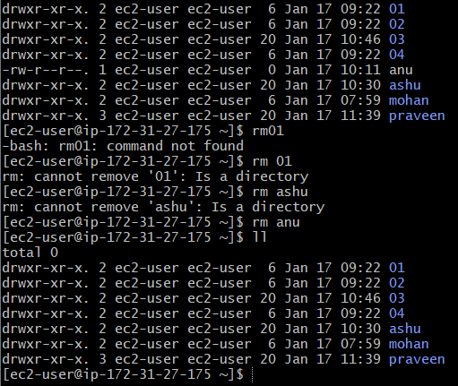

12. Grant or revoke permissions on a file or directory.

Premission of a owner of a file

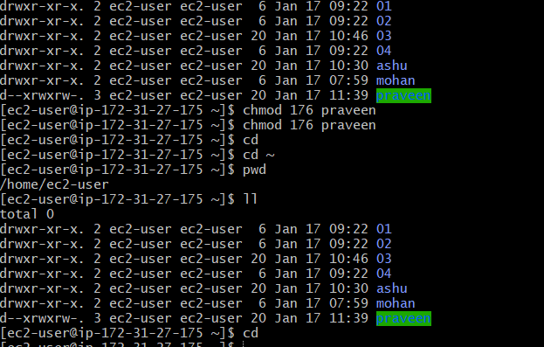

13. View the current date and time.

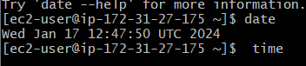  
14. Check the system uptime

We have to check the users

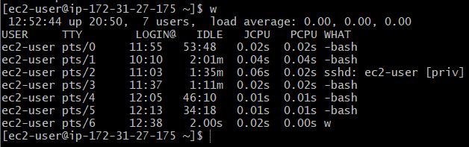

15. View the running processes.

To see the running proesses means what we to have doing

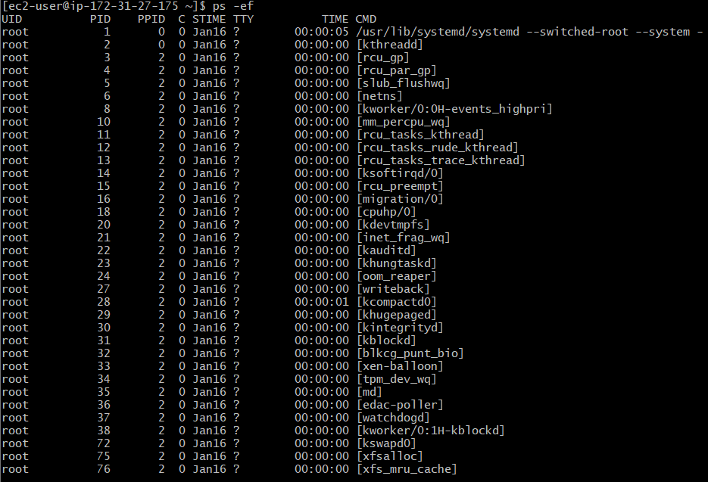

16. Kill a running process.



17. Install a package using the package manager (e.g., apt or yum).

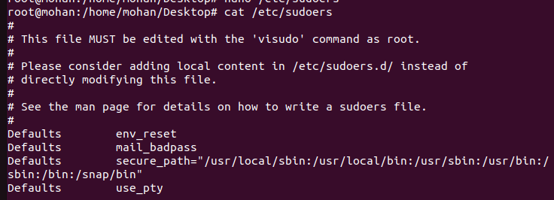

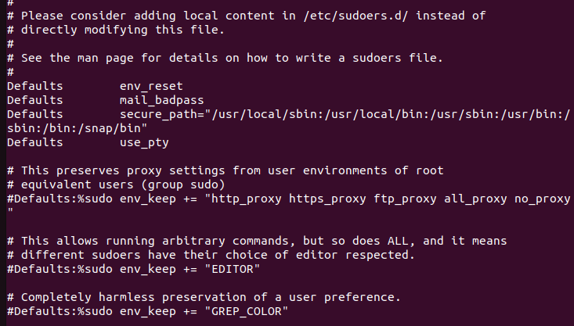

18.Update the system packages

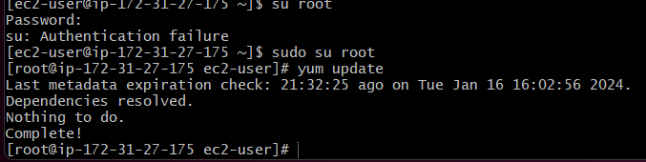

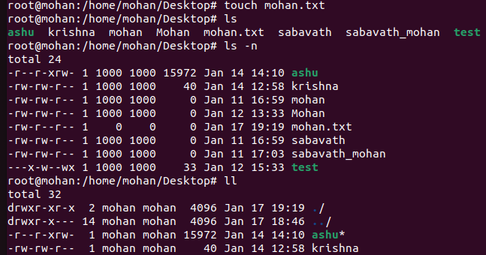

19. Create a symbolic link.

20.Search for files using the find command

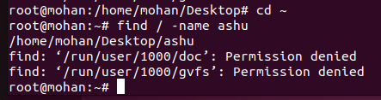

21.Compress and decompress files using tar.

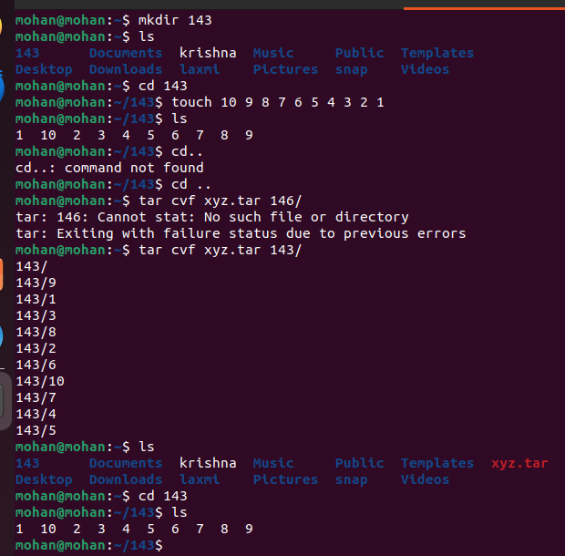

22.Monitor system resources with top or htop.

(Monitor system resources with top or htop).

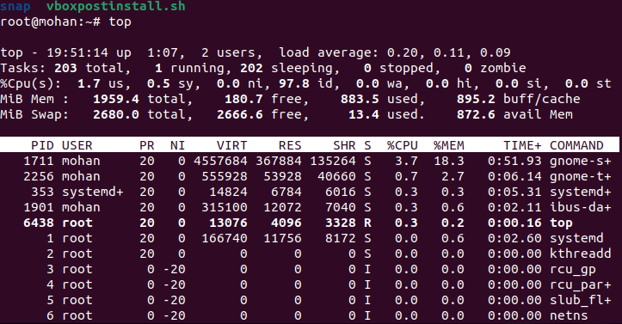

23.Create and manage user groups.

chown user:group /pat to destination/file or directory

chgrp groupname /pat to destination/file or directory

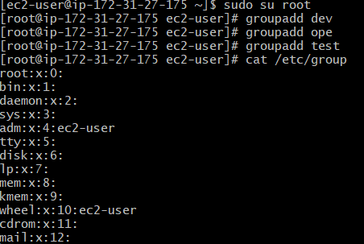

24.Set up SSH password less authentication

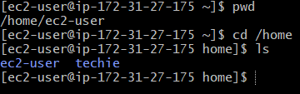

25. Monitor log files using tail or grep.

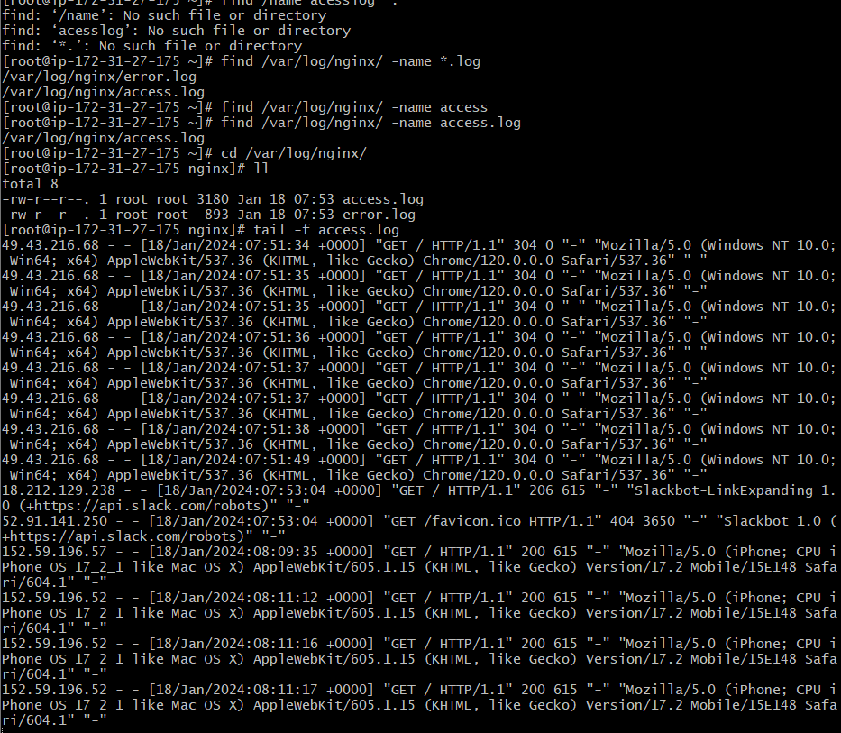 By using this command tail -f /var/log we can monitor the files

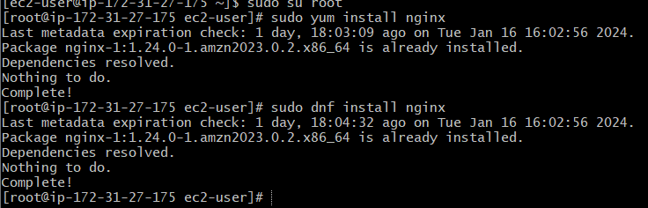26. Set up a web server (e.g., Apache or Nginx). 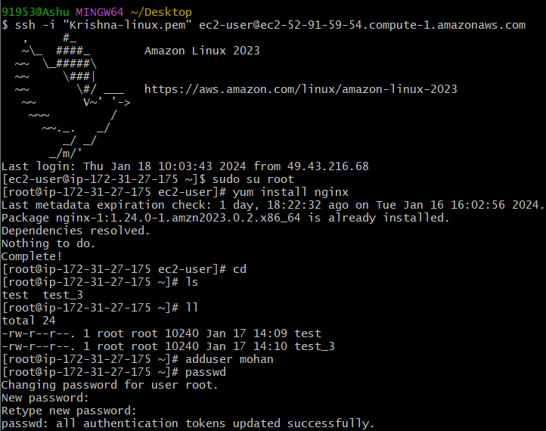

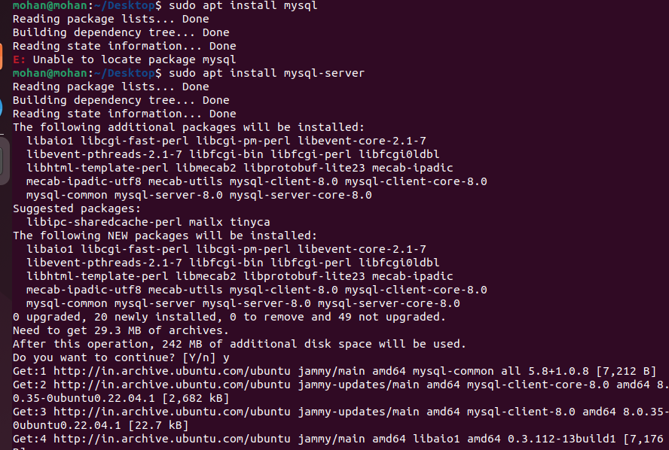27.Configure and secure a MySQL Database.

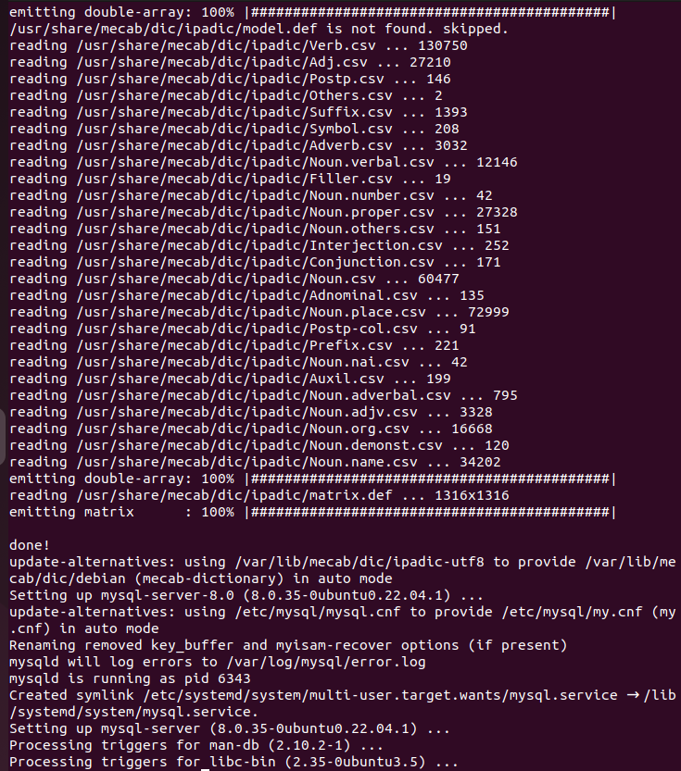

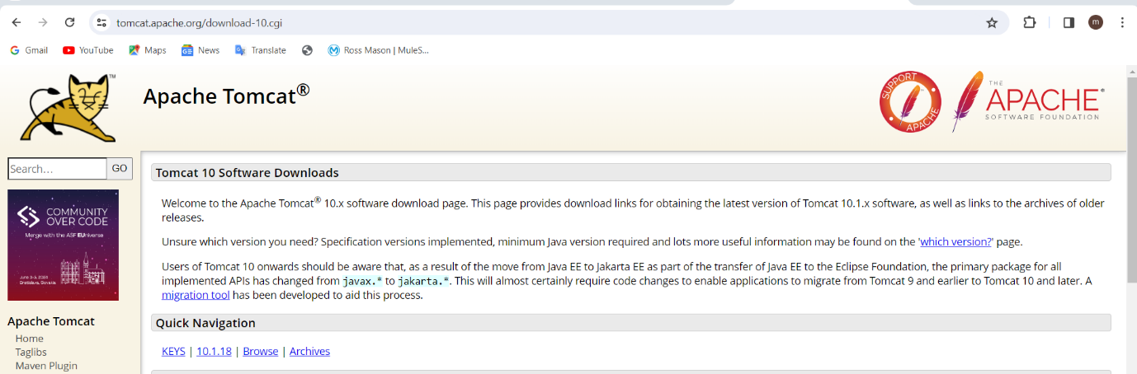28. Set up a Application Server (e.g.,Apache)

28. Set up a Application Server (e.g.,Apache Tomcat)

29.

30.

31. Print specific columns from a delimited file.

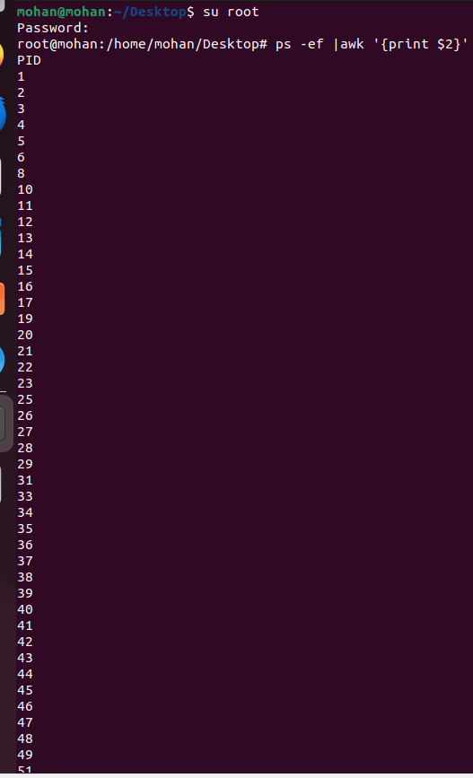

32) Calculate and print the average, sum, or other statistics of a column.

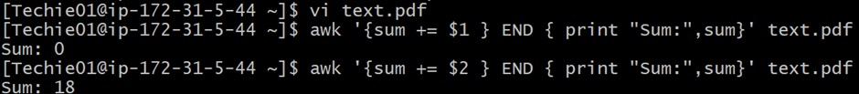

33) Perform string manipulation, such as extracting substrings or changing case.

34) Count the occurrences of a specific pattern in a file.

35) Sort lines based on a specific field or column.

36) Merge multiple files based on a common field or column.

37) Substitute text in a file using search and replace.

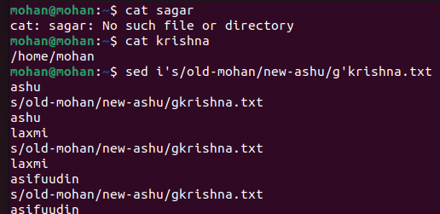

38) Delete specific lines based on a pattern or line number.